REJ™ (Rapid Economic Justification) Framework
Maximize Value to Maximize Your Success


Introduction

Giuseppe Mascarella and its REJ Initiative team has been keen in investigating why certain organizations achieve more value from the same technology. Among several factors REJ research has found out that successful organizations communicate more, build shared goals, involve business managers in the evaluation innovation and the key catalyst for this best practices is the efficient development of an Economic Justification seen not as a document but as a Business and IT Governance improvement tool.
CFOs and CEOs are increasingly demanding clear quantifiable benefits to the business from these IT investments.
How can organizations rapidly develop economic justifications when Company executives want to know the business impact of investments in IT infrastructure in relation to investments in other strategic parts of the business, such as R&D, manufacturing, and sales and marketing. Some companies are even requiring IT investments be mapped to shareholder value. Bottom line: IT Managers in a proactive or in a reactive mode, today, must be able to show their CIOs or CFO in hard numbers what kind of a return they can expect on their IT investment. But determining the bottom line when it comes to IT investments isn't always an easy thing to do.

Traditionally, companies evaluate IT investments on the basis of IT (itself)cost savings. Methodologies tend to focus on Total Cost of Ownership (TCO) and the strategic role of IT driving new opportunities for the business is sometimes ignored. This scenario with lack of communication with the business leads to possible cases of IT savings but possible business limitations in the flexibility for the business needs. In this light, IT's benefits to the business can be difficult to quantify, and as a result are often left out of the business case. But though traditional accounting methods make it awkward to absolutely quantify IT's value, that doesn't mean the issue of IT's value should be ignored.

The economic justification of IT projects has been researched extensively in the past decade including a wealth of publications from universities and consulting firms. While the models and techniques developed through this research provide a high degree of precision and mathematical certainty, they require extensive data and time to prepare. Our research shows that IT managers need a new Rapid , pragmatic, and quick approach to understanding and quantifying the value of IT investments.

What is Value of an initiative?
A business performance improvement, aligned with organization CSFs, making optimal use of resources with acceptable risks.

What is Rapid Economic Justification?
Rapid Economic Justification (REJ) is an open framework to help IT professionals analyze and optimize the economic performance of IT investments, and appropriate optimal resources and capital for IT projects. The core premise of this framework is that it is “business centric” and drives to align business priorities and IT investments.

The focus is on business improvement, which may include operational efficiency as an important element, but not the primary focus. In a collaborative process, REJ enables both business and IT stakeholders to understand how technology capabilities can improve the metrics that define success for the business.

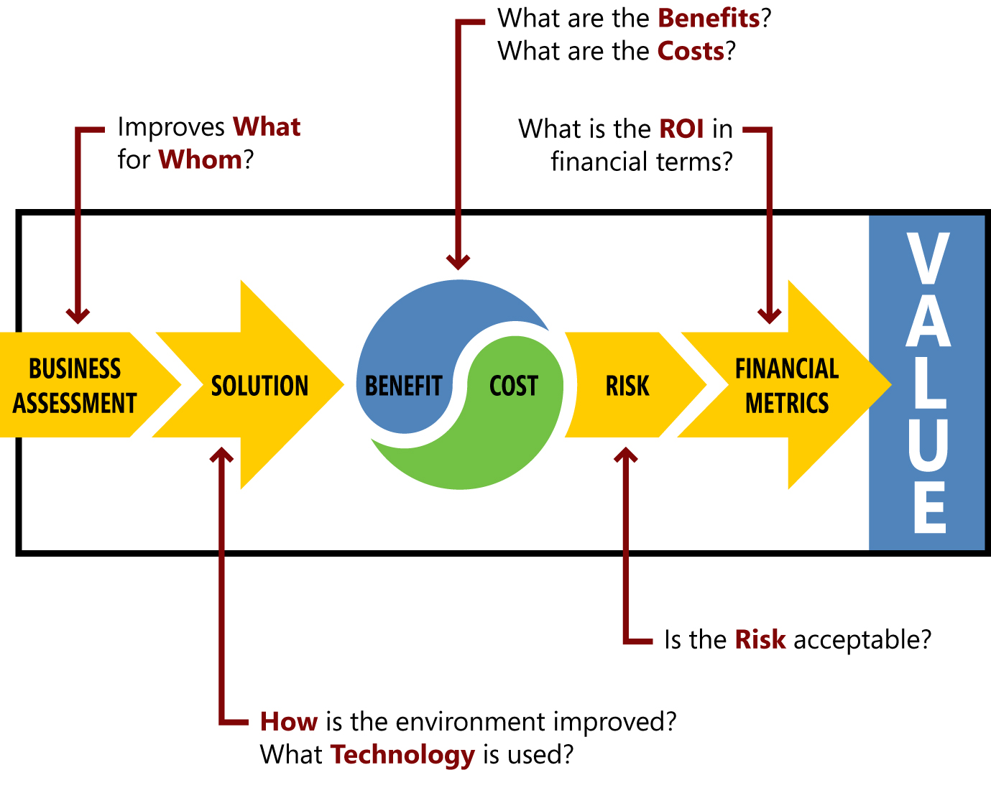
Figure 1 - REJ Steps: The REJ process consists of five steps, resulting in new optimization opportunities for your IT project. Each step focuses on a specific dimension of the economic analysis.

REJ work starts with the understanding the business and ends with the metrics to explain value to non IT managers. Each step is articulated in the language of the business, so business executives clearly understand the tangible impact of the IT initiatives and gain a greater understanding and appreciation for the strategic implications of IT investment. This method is faster and more flexible than traditional methods, and produces just enough data to avoid the analysis paralysis that can often occur in developing a business case.

How is the Rapid Economic Justification Framework Used?
The REJ Framework follows five logical steps represented below to derive the business value.

Step 1: Understand the Business

Value, like beauty, is "in the eye of the beholder," which is why the business and IT team members need a clear map to achieve a common perspective of what really drives the business and its investments. The Business Assessment Roadmap, shown below, identifies the key stakeholders, their critical success factors (CSF), the strategy to achieve them, and the key performance indicators (KPI) that determine success.

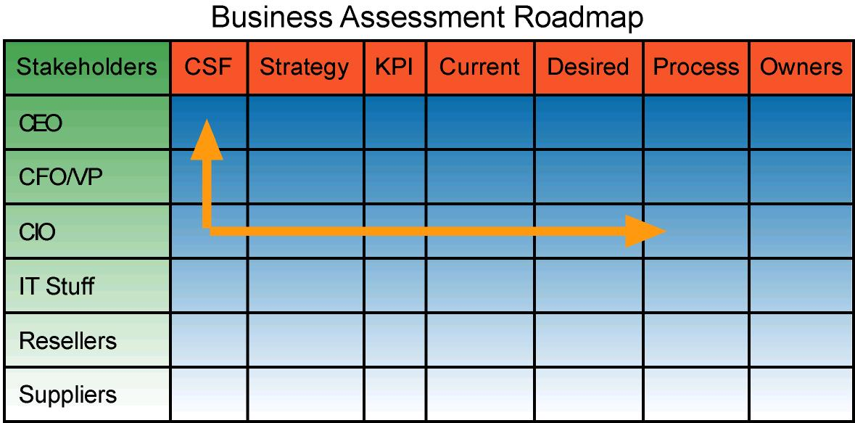
Figure 2 - Business Assessment Roadmap

Step 2: Understand the Solutions
Next, the project team will work with the owners of the key business processes using flow charts, fishbone graphs, and process analysis to identify ways of applying technology solutions to increase alignment with the organization's critical success factors. For every opportunity solution the team needs to document links between: IT Capabilities to enable changes, Product Features and Benefits.

Step 3: Understand the Benefit/Cost Equation
The benefit calculation in REJ goes beyond just an itemized list of benefits for the IT budget owners, and beyond the IT savings generally highlighted Total Cost of Ownership (TCO) umbrella. Benefits need to be expressed in the language used by the business decision makers to obtain their sponsorship. Such a step will facilitate the “Change Management” part of value realization.

The transition from Step 2 to Step 3 in understand what solution addresses KPI and what aligned benefit Technology brings requires a discipline in the building the Economic Justification
Table 1 – How to Project Benefits of an aligned Solutions
Step | Scope | Approach
Analyze | With the intent of impacting positively the KPIs, identify: Business Benefit, Business Changes, Enabling Technologies | Use Process and Business Function Analysis to understand the environment and find ways to either: Automate, Disintermediate, or Finds Synergies.  USE Cransfiled university BDN (Benefit Dependency Network)
Profile | To credit the project for all the benefits not just the obvious IT centric savings or revenue generating, we recommend to explore the impact on Protect Revenue and Avoid costs. | REJ Benefit Matrix see below
Quantify | The common and unifying language for IT and non-IT management is money. The CIO of Fedex use to say: If I can’t Measure It will not get done. Quantification is a managerial tool for change management. | Quantify the Unquantifiable Toolkit, project data from case studies and reliable ROI calculators.

The REJ Framework emphasizes the role of the 4x4 REJ Benefit Matrix since very often IT business cases end up justifying IT project as IT operations initiative. Asking more money this year in order to reduce IT budget (TCO) next year. Well, the reality is that next year the business will require functionalities, such as mobile wireless computing, that will not allow TCO reduction as promised. Long term the approach of justifying innovation as IT operations without educating the business during the process of building an economic justification could leads to a culture of: “It for the Sake of IT” or can leadibusiness manager to see IT as a “Black Hole” that doesn’t deliver on the premise that technology needs to be used to enable better business performances.
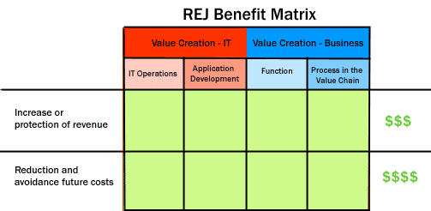

Figure 3 - Benefit Matrix

An example could be useful at this point to understand the 4x4 REJ Benefit Matrix. Let’s take something very basic: Microsoft® Windows and Office upgrade, for the IT part of the table newer technology is going to make several IT operations task better, list them tehre. For the right side of the matrix, could this project help the sales force “Function” communicate more effectively with partners and customers? Sign contract with a eSignature thanks to a PKI certificate automating cumbersome “Processes in the Value Chain”. Making easier to do business can generate more sales and help reach next quarter's sales goals. The same upgrade will also help the Human Resources “Function” manage and share documents better, which will improve the turnaround time for making new hires. The same IT solution can help in avoid costs of returned items for miserunderstandings due to a lack of prompt communication flow.

Finally, the team will quantify benefits using tools such as Expected Monetary Value, Real Option Theory, Five Steps to Productivity, etc. Giuseppe Mascarella and the REJ community on Facebook or Linkedin will be available to share relevant data points from other organizations that authorize their use REJ provides the modeling tools that leverage rich industry databases from the Gartner Group, IDC, META Group, Navigant and others to optimize the cost/benefit analysis.

Step 4: Understand the Financial Metrics
Finally, the team translate the initiative in the language of the CFO and controllers, by projecting the impact of the proposed IT investment in a cash flow using financial terms (such as IRR, NPV, and payback period) used by a specific company to present the business case for any investment. Most of the financial decision makers like to see a proposal with options (i.e, do nothing scenario, do it slowly, do it in large scale right away) to have the flexibility to approve a good project eve if the global portfolio context could make this very difficult.

Step 5: Understand the Risks

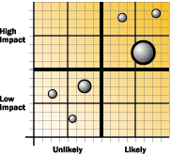
A project can have a good ROI and not being approved, just because it carries risks that are not acceptable by the organization and stakeholder culture at this point. A good risk analysis should help the project owner develop a mitigation plan and re-assess the solution and the projections. The sponsor this point needs to disclose the risks that he believes are not worth to invest to be mitigated.
The various categories of risks are profiled for their probability and impact using a matrix. This provides a visual representation of the risks associated with the project and the ability to perform sensitivity analysis and develop the necessary risk mitigation plans to optimize the economic impact.
Figure 4 - Risk Profiling

Summary
The Rapid Economic Justification framework builds a bridge of common language between IT and business executives to demonstrate how investments in IT benefit the business. This framework ensures that the IT projects are aligned with the specific business strategies and priorities; and that all stakeholders (business and IT) are committed to both the process and the final results. This leads to a successful change management phase in realizing the benefits.

Conclusion
For more information
For additional information about the Rapid Economic Justification consulting offering, please contact giuseppe@valueamplify.com or the members of the communities on Facebook and Linked To download tools please also refer to http://www.valueamplify.com. Join the news feed on Facebook REJ (Rapid Economic Justification) in Linkedin.

